Table Lamp
Version 3.0
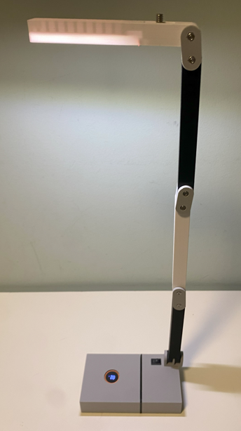

Project Goals
Improve the Table Lamp in 3 different areas:
- Make it lighter using small screws
- Align the lamp and the base adding a rotating joint to the base
- Add experimental support for CV60 camera

Dimensions
Base Size: 140x77 mm (it was 140x90 on version 2.0)
Closed Height: 56 mm (it was 75 on version 2.0)
Open height (or Lamp distance from the ground): 480 mm (it was 490 on version 2.0)
Weight: 402! Since it was 494 g on version 2.0, this is a big achievement!

Images
This is the lamp closed:
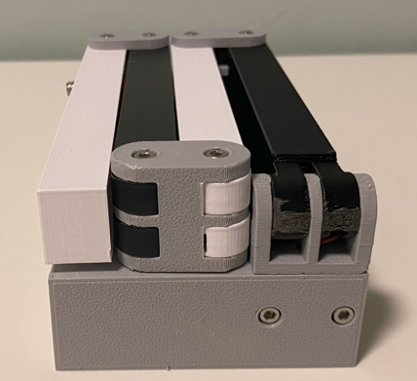 | 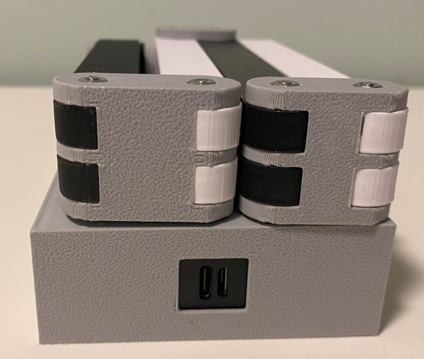
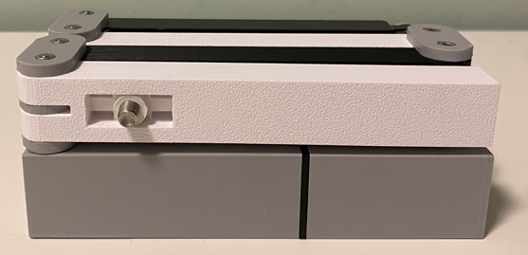 | 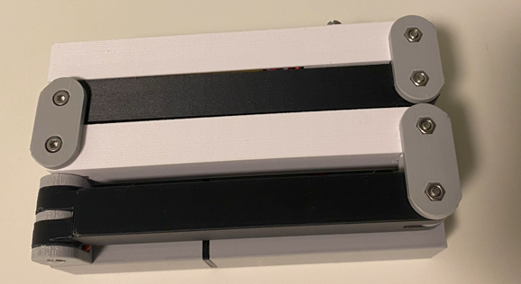

And this is the lamp in full swing:
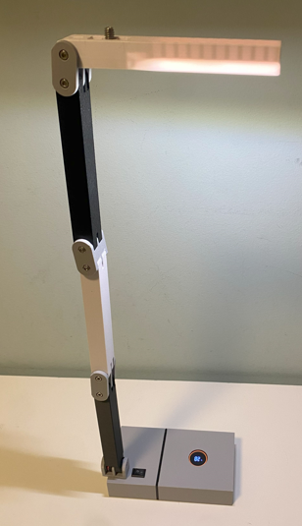 | 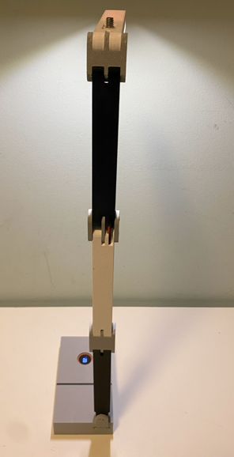 | 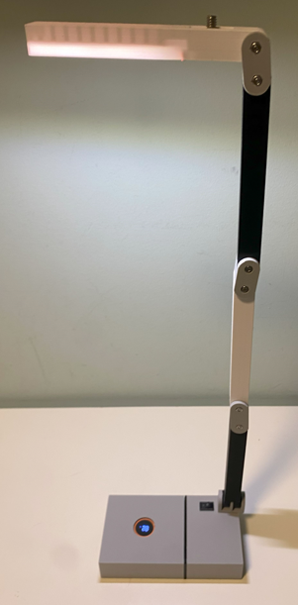

Components

Power bank
This is the power bank I have incorporated in the project.
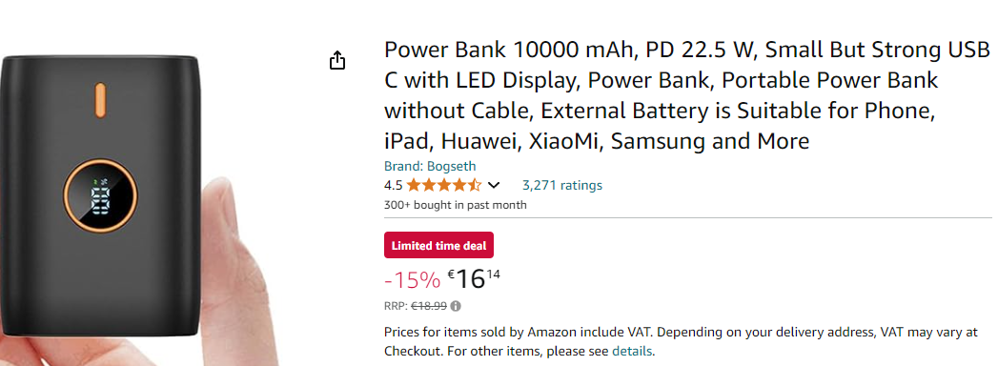
Amazon Germany: https://amzn.eu/d/j4mhf3Z
Amazon Italy: https://amzn.eu/d/agR1Bto
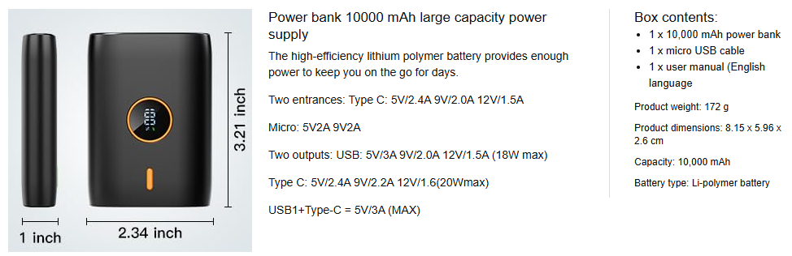

Why I choose it:
- Because it has a capacity of 10Ah
- Because it has a USB A on one side and USB-C / Micro USB for charging in the opposite side. This make possible the connection with the lamp on one side and leaves the charging connectors available on the other side.

Switching regulator
This small circuit trigger the USB port of the Power Bank and then convert the USB Bus voltage up to 28 VDC. For this application I have adjusted the output to 24VDC.
The input cable is a USB-A, and it has been cut on the other side.
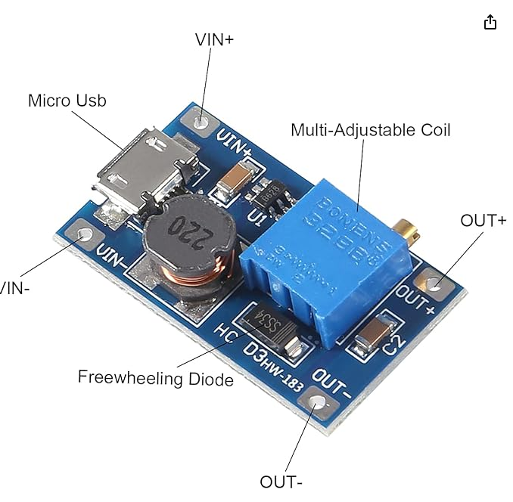

Since the required power consumption is very low (0.76W), I use directly the Bus Voltage (5V) to get the 24VDC for the LED. The resulting input current should be 150 mA.

LED Strip
I use 2 Modules from 24 VDC COB Led Strip, Natural White. https://amzn.eu/d/dCH8eCl
2 modules => 0,76W
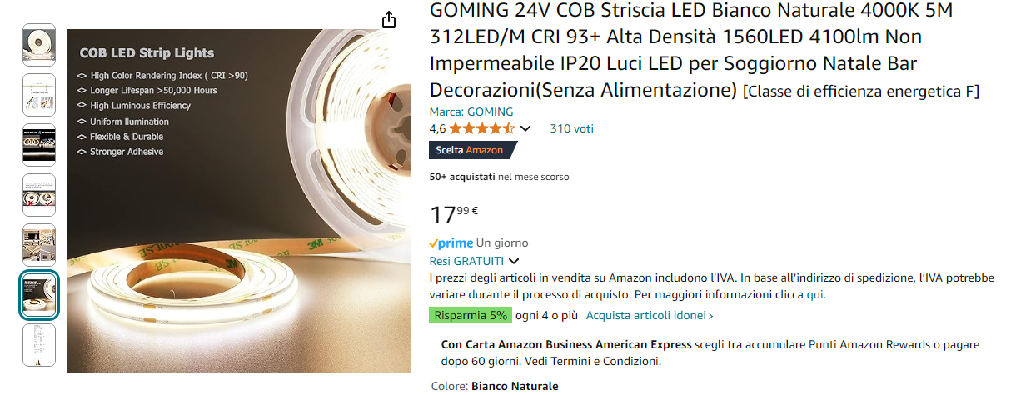
Considering the strip power is 50W/5m, so:
- every module we have: 50W/(5000/38) = 0,38W
- Since I use 2 modules, I have a max power of 0,76W
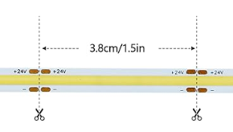

Mechanical Elements
The base length is equal to the beam length: 140 mm.
The width is: 28 + 16,5x2 + 16 = 77 mm.
The base height is 28 mm.
The base of the lamp is made in 4 parts to contain the battery, the switch and the electronic board:
- Battery Holder
- Battery Closure
- Battery Cover
- Base Joint
- Rotating Joint Lock
The arm is made by:
- 1 x Dual Axis Beam
- 1 x Long Joint
- 2 x Beams
- 2 x Short Joint
- 1 x Lamp
Accessories:
- CV60 Camera Holder

Battery Holder
This is the biggest block in the lamp base. It is mainly designed around the power bank.

Top View
The battery holder is created vertically, and the base size is 77 x 28 mm
The charging slot in the center is 15x13 mm and it is located in the center.
The battery compartment is made of 2 x 27 mm cylinders, 33 mm spaced. The circle is curtailed in the top and bottom side.
The battery total length is 82 mm
The top and bottom walls are 1 mm thick.
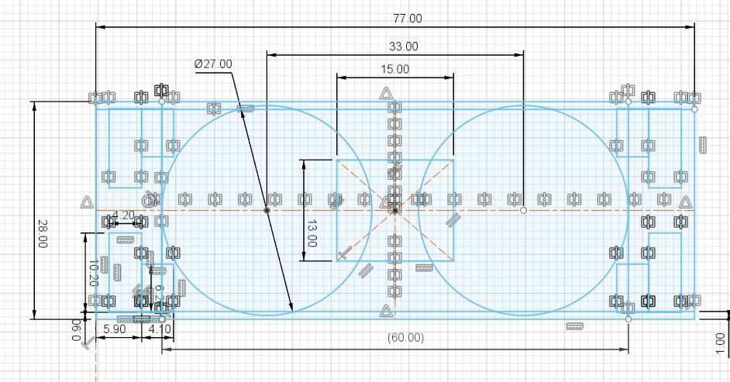

Locking slots
On each corner there are 2 slots used to keep the cover and the battery closure in place
They for an L shaped slot, 4.20 x 10.20 mm

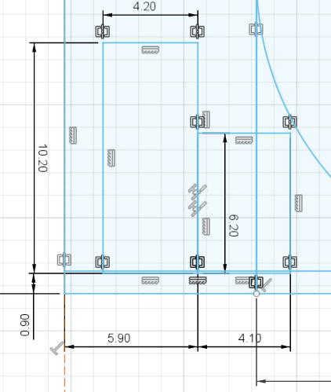 | 

The slot deep is the total length of the Battery Holder, except the wall.
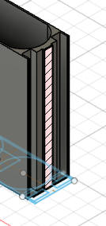

State of charge Display Hole
There is a hole in the top side of the base so the state of charge is visible.
The bottom wall is 1 mm thick.
41.25 is the distance from the USB-A connector
The total height of the battery is 82 mm + 1 mm for the bottom wall.
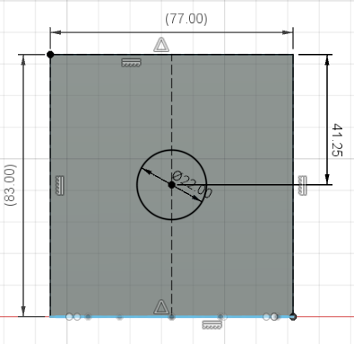 | 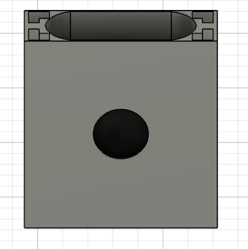

Charging slot details

The charging slot is 15x13 mm large, in the center of the battery bank.
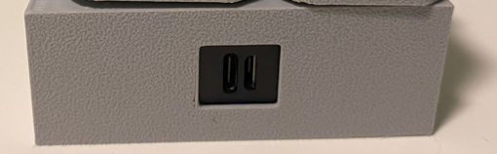

Battery Holder Resulting 3D layout
The battery holder is printed in Gray and with the charging slot on the bottom.
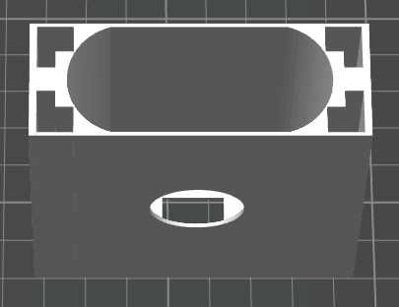

Battery closure
This is a cap for the battery compartment and it is used to keep the battery in place, while leaving space for the electronics and wire in the Cover.
The base dimensions are the same as the battery holder: 77 x 28 mm
In the center there is a USB-A 15 x 20 mm connector slot used to plug the electronic board into the power bank.
The locking is possible thanks to 4 pins that are 4x6 mm.
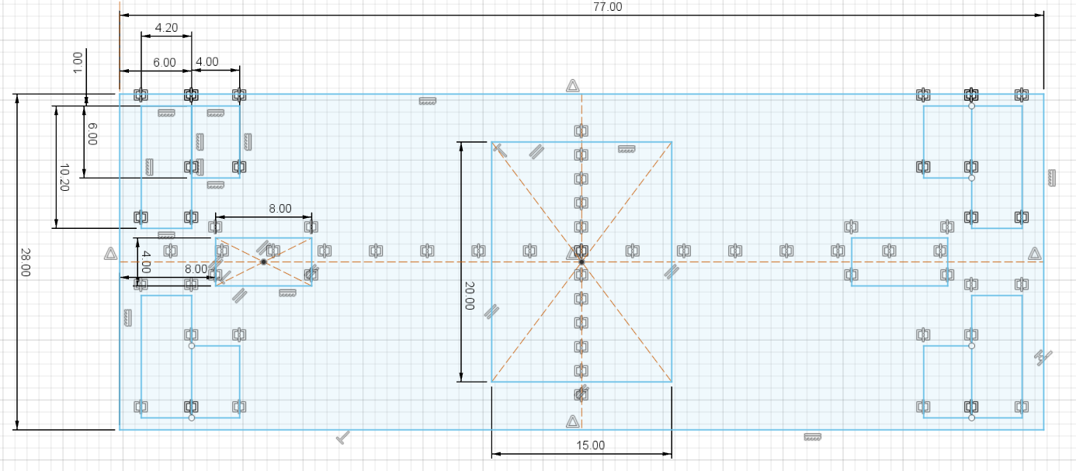

Battery Closure Resulting 3D layout
This component is printed black to create an edge between 2 gray parts.
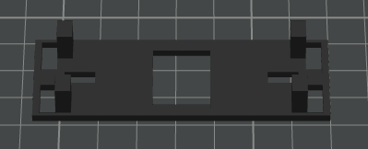

Battery Cover
This is the final component of the lamp base and it has space for wiring, for the switch, for the rotating joint lock and for the electronic board.

Top View
The base dimension is 77 x 28 mm, like the Battery Closure and the Battery Holder.
Since this component should bear the arm, the wall thickness is 2 mm instead of 1 as in the Battery Holder.
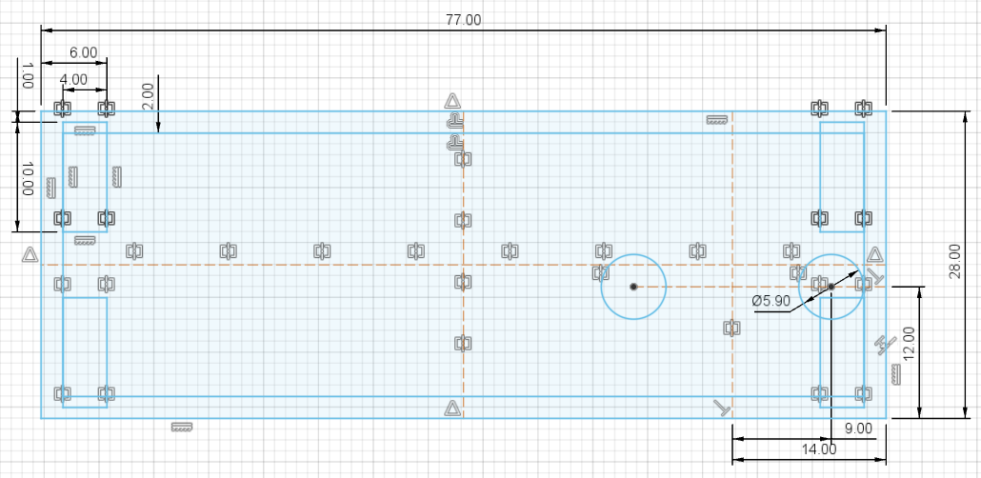

Rotating Joint Lock details
To hold the Joint Lock in place I use 2 x 6 mm cylindrical head screws.
Since the cover wall is 2 mm thick I cannot hide the screw in the wall, so I create a 5.90 mm hole for each screws so I can get 2 mm and then I get the remaining 1.2 mm from the Rotating Joint Lock.
This is possible because the 2 screws are used to keep the lock in place and prevent moving X, Y. Once the lock is in place it cannot move because of the axis of the joint.
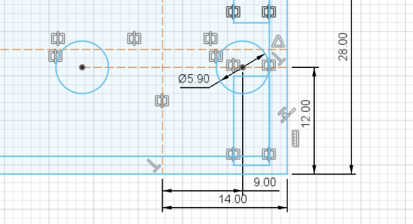 | 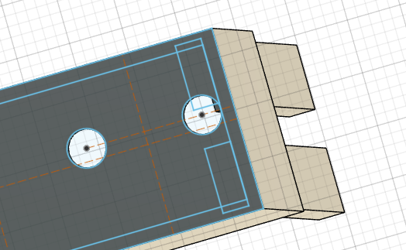

Locking pins
4 Pins 4x10 mm big are placed in the corners to lock the cover into the battery holder. The resulting lock is not great, this point need improvements.
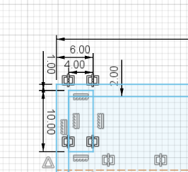 | 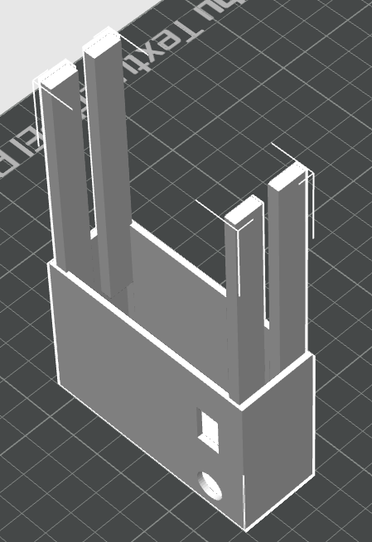

Power Switch Slot
Below the dimensions for the slot used to fix the power switch.
The size is 14 x 8.50 and it is 14 mm far from the Battery Cover edge.
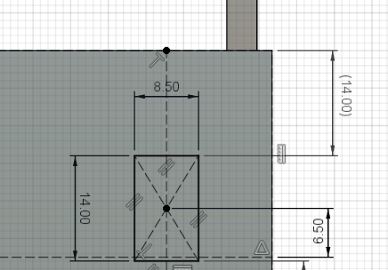 | 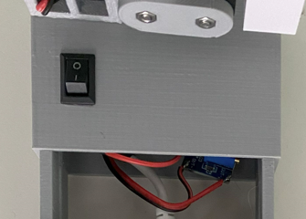

Rotating Joint hole
The rotating joint requires just a 10.10 mm holes, because the burden of creating a hinge is managed by the Rotating Joint Lock.
The Rotating Joint is placed 8 mm / 14 mm from the edge.
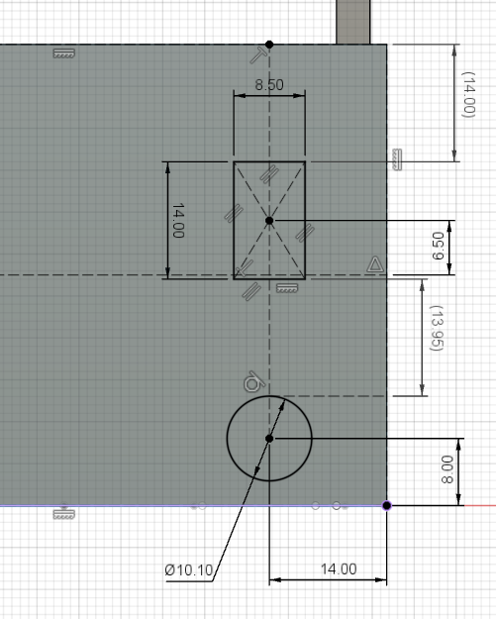 | 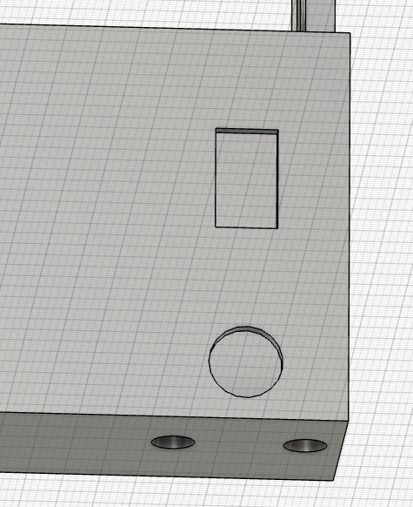

Electronics
The electronic board is connected directly to an USB-A cable without using the connector in order to save space. The positive bus voltage is interrupted by the switch.
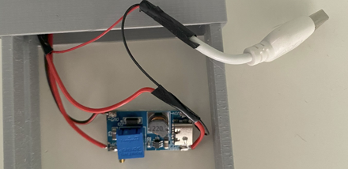

Battery Cover 3D Layout
The best option is to print this component vertically.
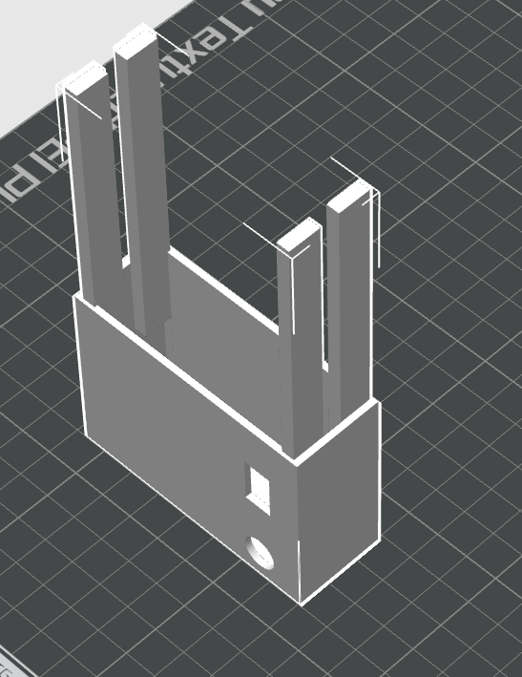

Lamp Base Assembly
This is the final assembly for the lamp base.
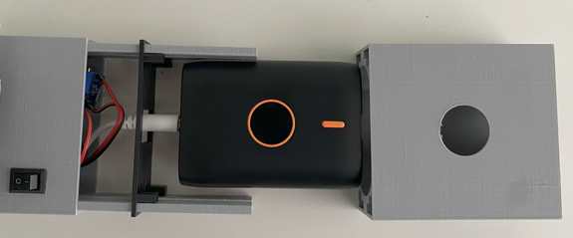

Base Joint
This is the mechanical element that connect the battery cover to the arm.
It needs to allow a rotation of the first beam of the arm.
It needs to allow a rotation of the joint along the vertical axis. This increase the complexity and make it difficult to print.
Printing this part using PETG was unsuccessful because the resulting part was brittle and cannot withstand the mechanical stress of the hinge.
I solved it increasing the extrusion temperature to the maximum. The resulting part is very resistant.
I also add more layers to the walls

I also changed the filling from 15% to 25%


Top View
The base size is 16 x 28 mm
The 3 blade of the arm hinge are 4, 3 and 4 mm. The external are 4 mm so I can hide the 3 mm cylindrical screw inside the joint..
And the rotation hinge is generated from a 10 mm cylinder.
In the center there is a 4x4 tube used for the cable passage.
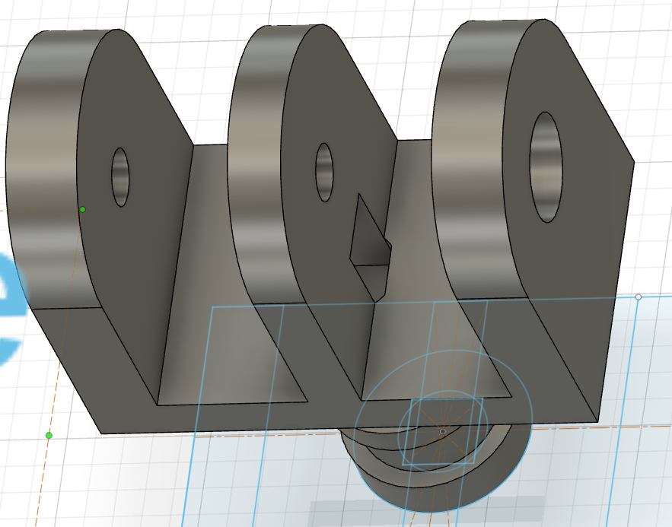
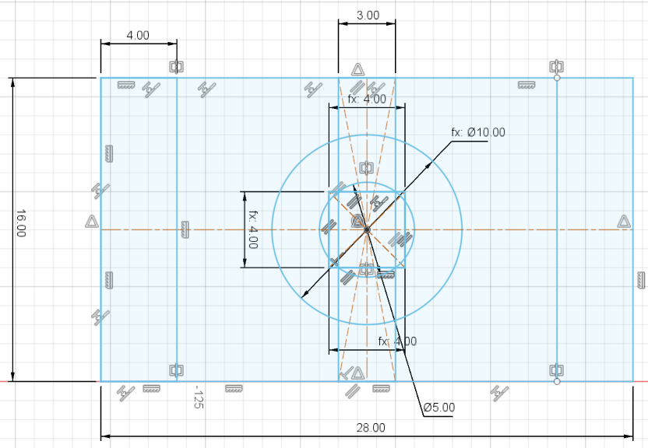

Base Joint Side Views
The hinge is generated from a 16 mm wide blade.
In the center there is the 3.20 mm hole for the screw.
On one side there is a 3.25 mm hexagon used to hold and hide the screw nut.
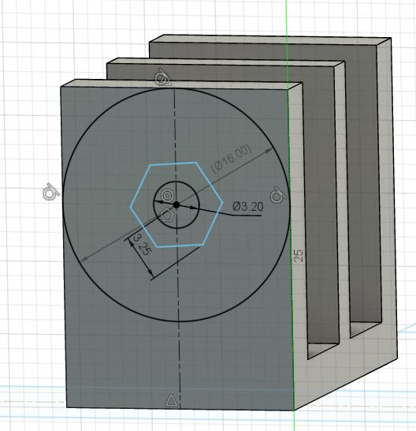 | 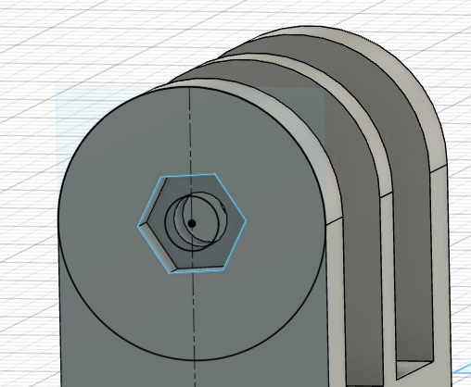

On the other side we have a 6 mm, 3.2 mm deep hole to hide the screw head.
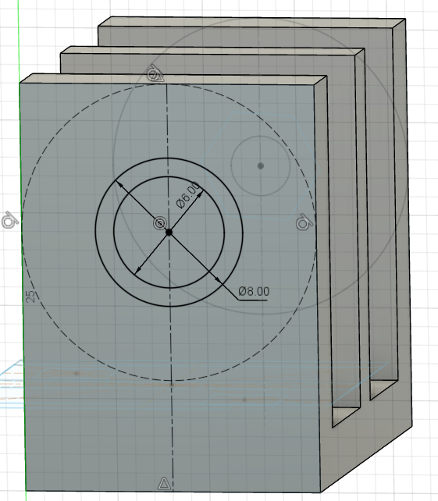 | 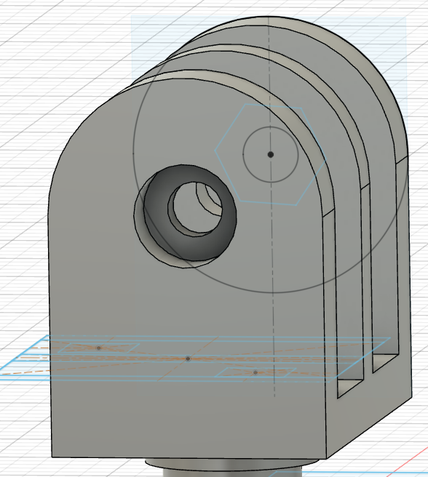

To guarantee the screw position, there is an 8 mm diameter / 1 mm extrusion that create a larger support for the screw and it is used to mate the hinge and the beam.
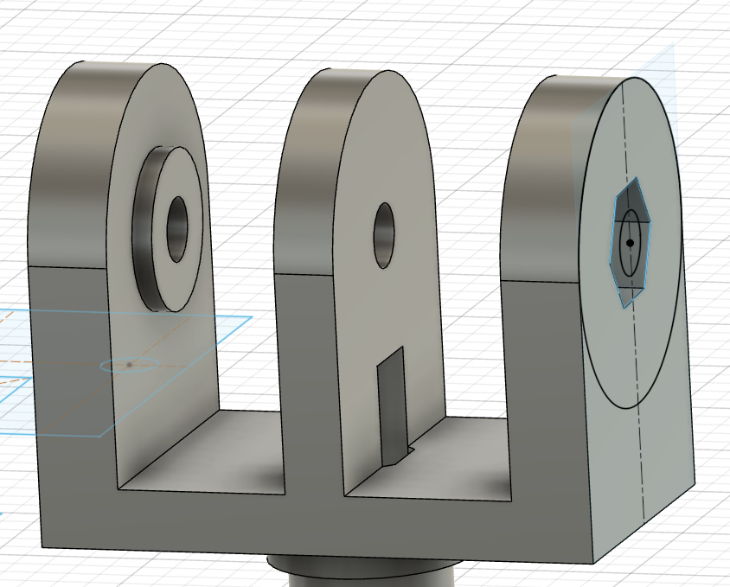

Base Joint Rotation hinge
The friction and the mechanical lock of the rotating hinge is generated by 2 slots that match with the Rotating Joint Lock.
I made the slot 4.20 instead of 4 mm so the friction is all on the flat surface not on the side.
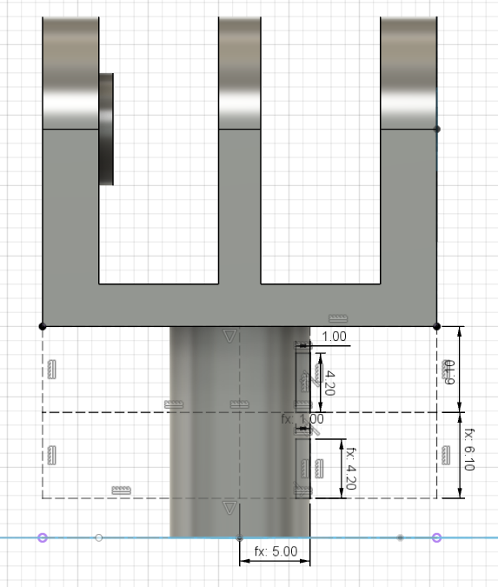 | 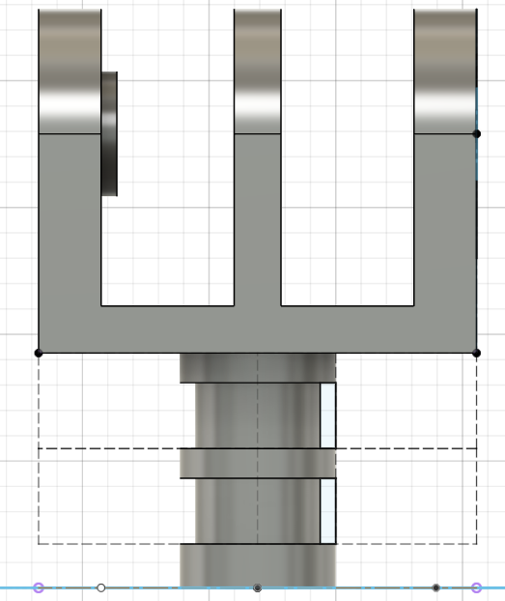

Base Joint Resulting 3D Layout
Printing this joint requires a vertical layout, to maximize the precision, and it requires also support.
Best results are possible using Tree Supports
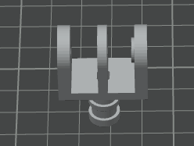 | 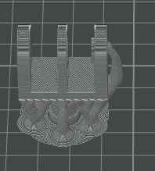

Rotating Joint Lock
This and the rotating joint are the most complicated components in this project. It takes me a lot of trial and errors to implement it in a satisfactory way.
This is made by two half and it is inside the Battery Cover. It is used to lock the vertical hinge in place and using the screws we can control the rotating friction.
See below how the 2 parts looks like, in the correct orientation, with the pin ingress from top.
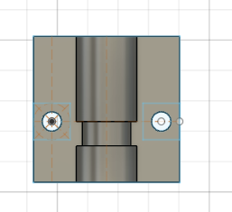 | 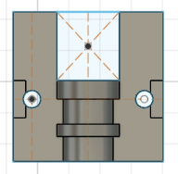

See below how it looks like inside the Battery Cover, right on the back of the switch and from outside with the 2 screws embossed into the Battery Cover side wall.
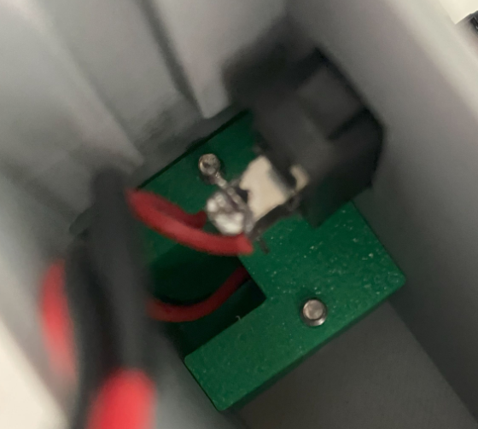 | 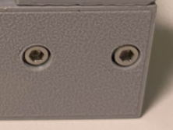

Back Half Top View
The base dimension is 24 x 24.
Why 24? Since the Battery Cover is 28 mm high and we have 2 mm wall thickness, the internal space is just 24 mm.
This is the drawing and the rendering, considering the hinge ingress from the top.
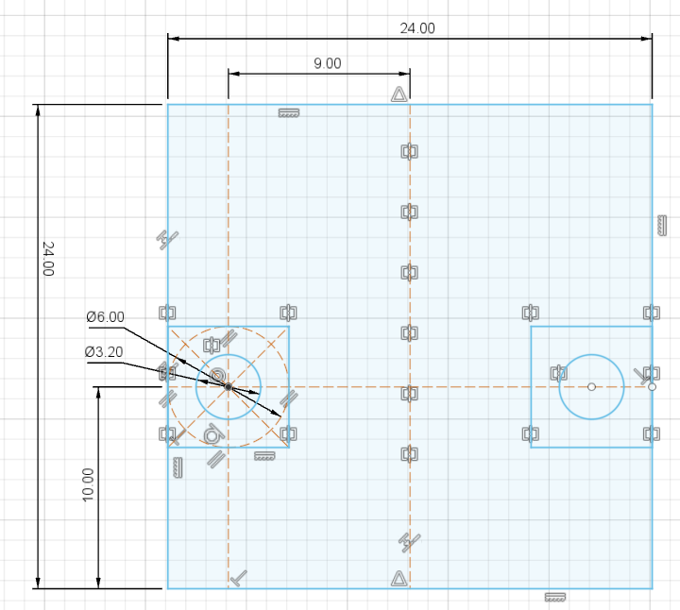

The screws are 10 mm from the top, not in the center, to leave more space on the bottom for the cable slot on the front half.
Since the 3 mm screws are just passing through, the hole is 3.20 mm.
To accommodate the screw head height, 2 mm are absorbed by the battery cover wall and the remaining 1.20 are covered by a slot in the back side.
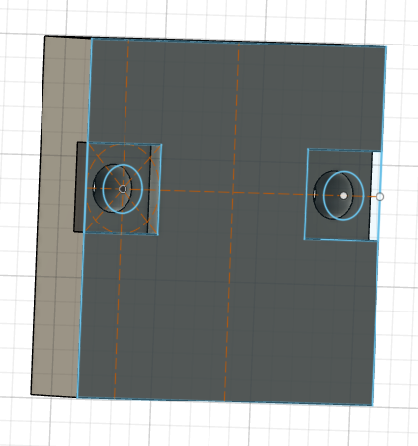

Back Half Side View
I use side view to create a semi-circular slot for the joint.
The Diameter is 10 mm and I create a half cylinder with an offset of 1 mm so I have room to squeeze the lock and make the joint stiff.
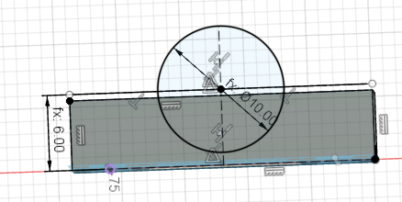

And then I create a 4x1 mm ring
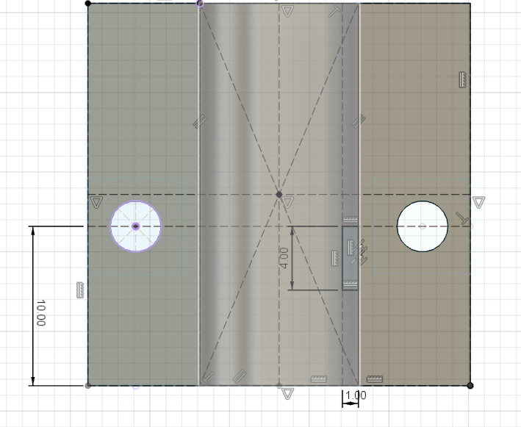 | 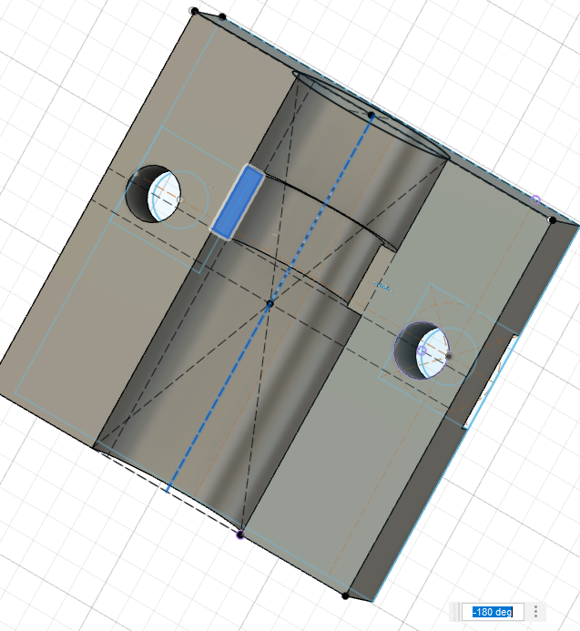

Front Half Top View
This part is mated to the Back Half and has a big slot in the bottom, to allow the cable passage.
Base size is the same as the Back Hald: 24 x 24 mm.
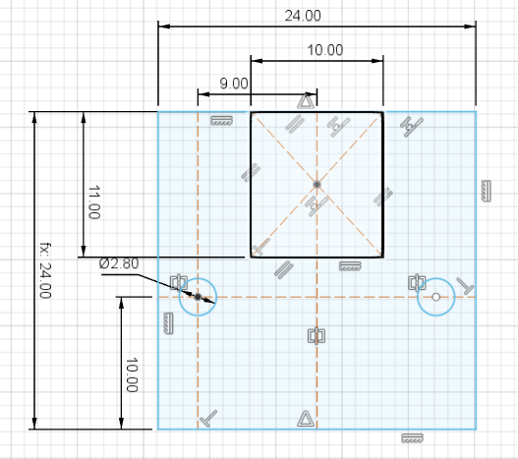

Front Half Top View
I use side view to create a semi-circular slot for the joint.
The Diameter is 10 mm and I create exactly a half cylinder.
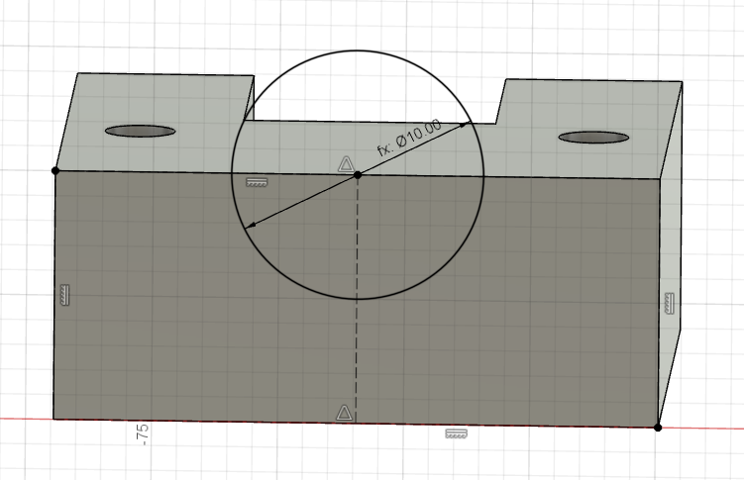

Then I create a 4x1 mm ring and a small 6 mm x 2 mm slot to use a screw and separate the 2 parts easily.
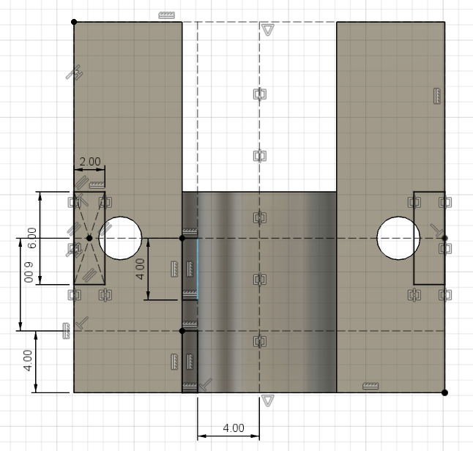 | 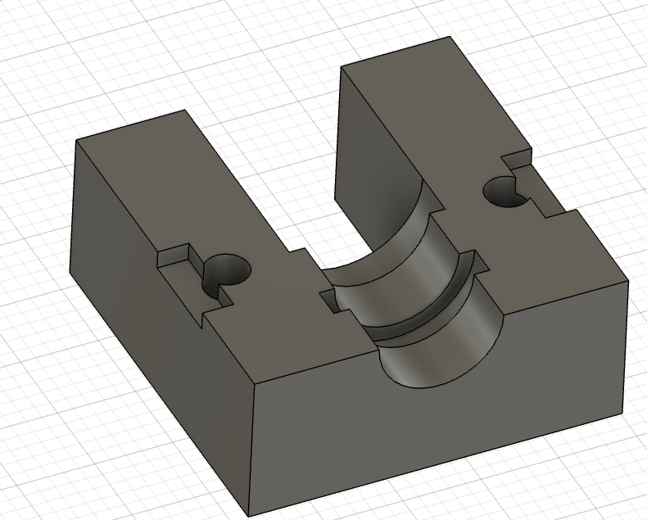

Rotating Joint Lock 3D Layout
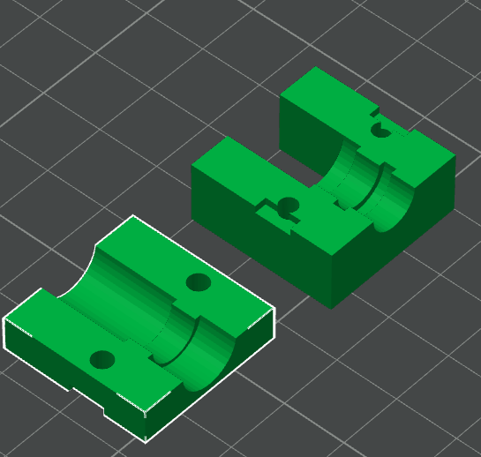

Double Axis Beam
This is the first beam and it has 2 rotation axis to allow the arm packed position.
I created it in vertical position so I don’t need to rotate it before printing.

Top View
The base dimension is 20x20. Since we need to connect to the base joint and to a joint on a different axis, on one side we have 20x20 but the central part of the beam and the other side is 20x16.
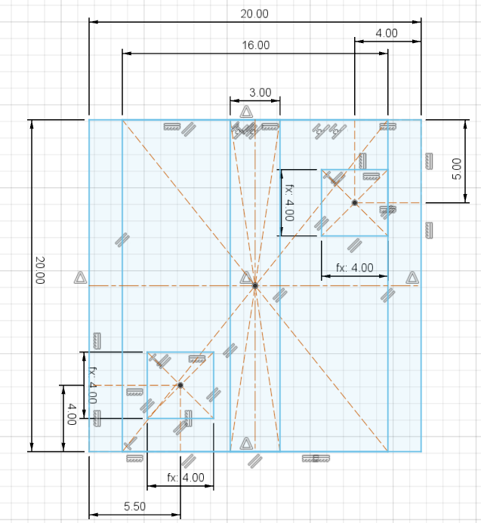 | 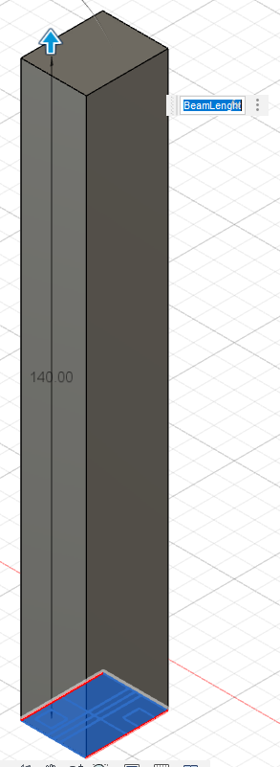 | 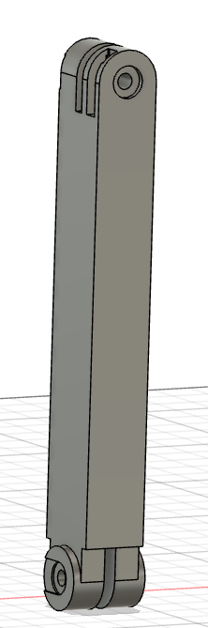

There are also a couple of 4x4 mm holes for the cable passage.
Starting from the Top View, the beam is extruded 140 mm

Beam Hinge
All hinges have a special shape to accommodate the bulge in the joint. The bulge is necessary to hide the screw. For this reason we have a depressed area that is 8 mm wide and a small slot on the side to allow the joint to slide in.
There is also a step the keeps the joint in place once in position.

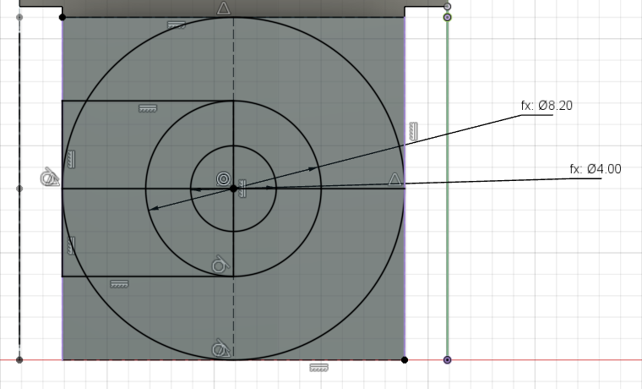 | 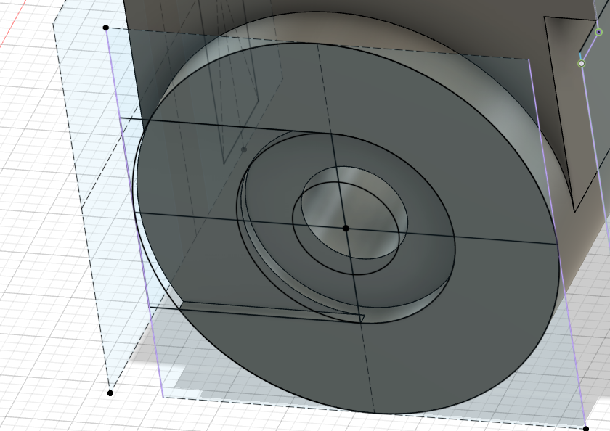

Slot Dept: 0.5 mm  Bulge Dept: 1 mm  This is only on one side | 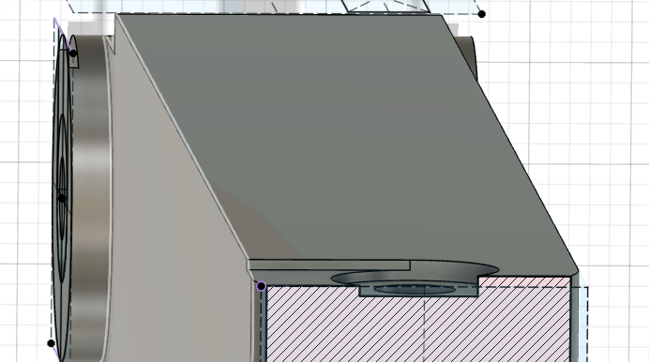

Long Joint

Beam

Short Joint

Lamp

Joint
Extrusion: in the center we need 3 mm slot, 16.5 mm deep
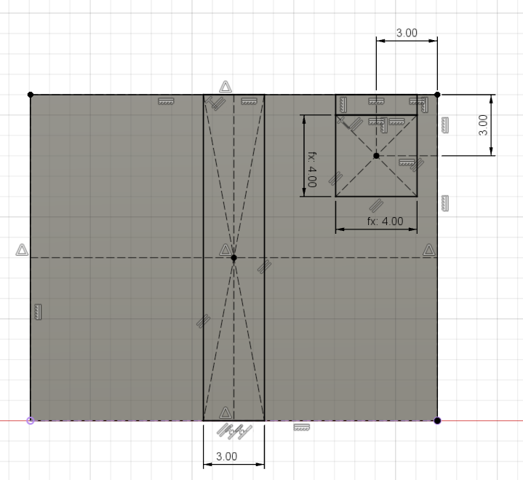

CV60 Camera Holder
This is an accessory that can be use to hold a CV60 camera in place, supported by the table lamp

CV60 Camera mechanical dimensions.
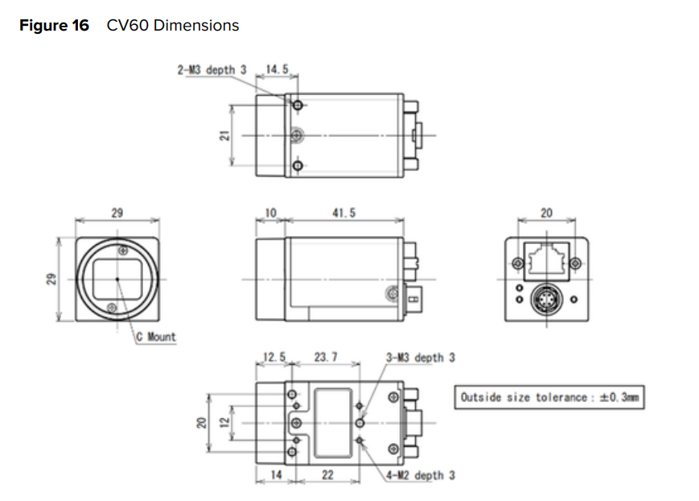

B.O.M.

Nuts and Bolts
For the battery compartment to lock the arm joint that allows the rotation
- M3x14 mm Bolts 2
For the arm:
- M3 x 25mm Cylindrical Head Screws 7
- M3 Nuts 7
Power:
- 2 x 0,13 red and black cable: 1 mt
- Power Bank
- USB to 24VD step-up converter
- USB A to C Cable
- Power Switch
- LED Strip
Accessories:
- 1/4-20 UTF Screw for the Manfrotto Telephone Holder

3D Printer Layout

Black
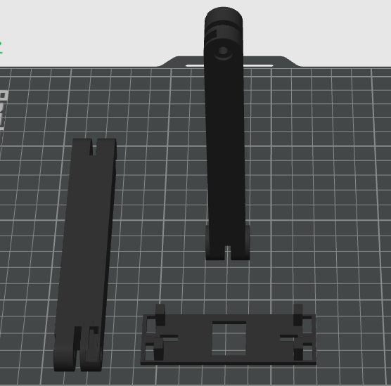

Gray
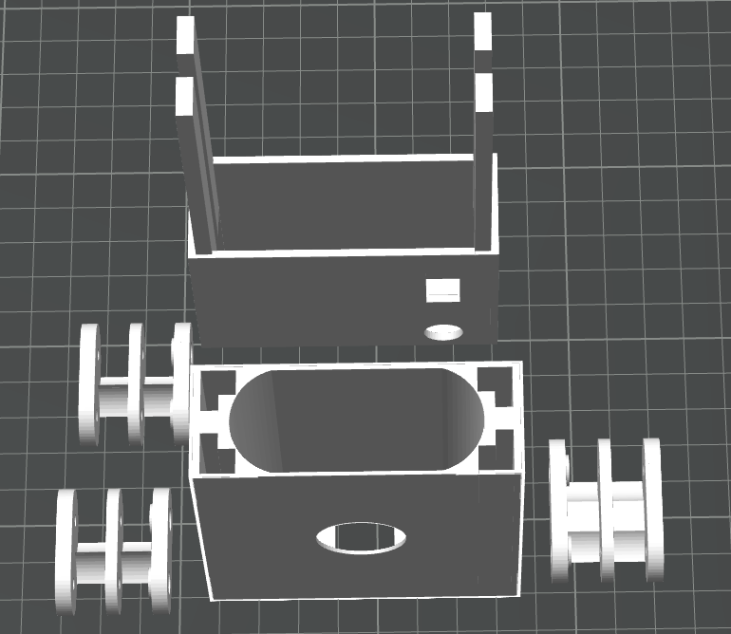

White
We need support to print correctly this parts.
This is faster and create better results than printing the lamp vertically.
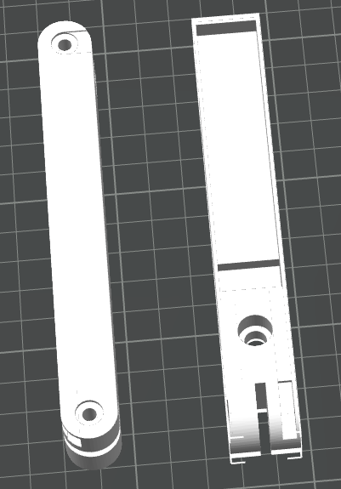 | 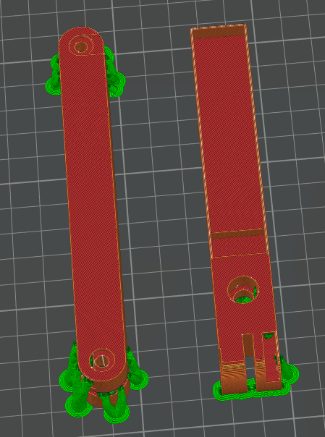

Camera Holder
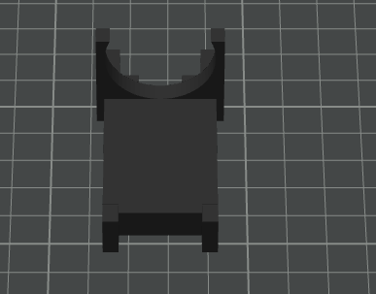

Suggestions for next iteration

Base Interlock improvements
Find a better way to lock the three components of the base. Currently I use some black electric tape and it is enough, but I think there can be a better solution that guarantee that we can remove the power bank without any tools and in the same time the base is locked.

Weight reduction
Additional weight reduction can be achieved working on the base and using a less resistant structure. But the gains we can get are maximum around 50 gr. In any case this means a final weight below 400 gr.
3MF File | Simulated Weight [g]
Table Lamp 3.0 BlackComponents-ReadyToPrint | 43,86
Table Lamp 3.0 GrayComponents-ReadyToPrint | 93,69
Table Lamp 3.0 JointHolder-ReadyToPrint | 4,67
Table Lamp 3.0 WhiteComponents-ReadyToPrint | 36,01
Table Lamp 3.0-BaseJoint-ReadyToPrint | 5,79
 | 184,02
Power Bank | 200

Many walls in the base can be shrunk from 2 mm to 1 or from 1 to 0.8.

Stability improvements
Add 4 Feet can improve the stability. The power bank in the center can create a little bulge.

Arm improvements
The base joint can be smaller and made for 16 mm. This will save the enlargement to 20 mm.  This lead to a 4 mm reduction in the base width (from 77 to 73 mm) | 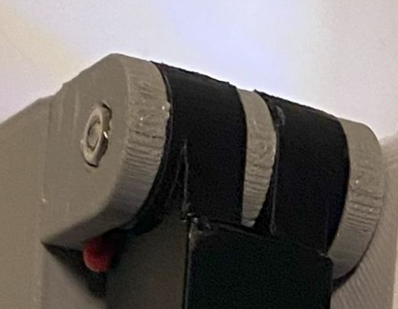

Colors
There are a few suggestions that need to be tested
- All White with Black Switch, black power bank (covering the orange / green ring), black battery cover.
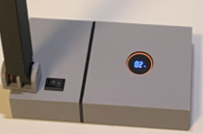
- All White and battery cover aligned with the ring color (green / orange)
- All green, with Orange insert to match the power bank SOC Ring and a white insert in the lamp.
- JuventusFC / INTER FC style / Milan FC style

Lamp improvements

More light power
Add a second strip in order to have twice the light

Touch Dimmer
Add a touch dimmer to control the light intensity

